# **Java Exercise date 19-02-2020 Part 1**

* **Question?:**

- Give explanations of overriding, overloading in Java

- Give some examples of overloading, overriding

* **Answer:**

Overriding and Overloading are two very important concepts in Java. They are confusing for Java novice programmers.

* **Overriding**
  + Means having two methods with the same method name and parameters

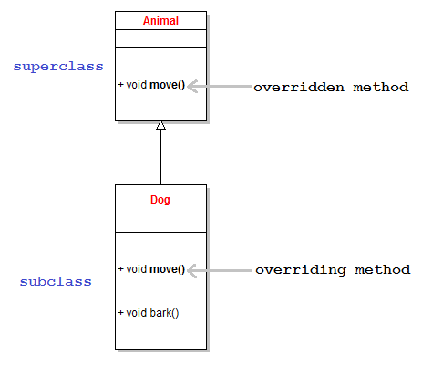

**Example Overriding:**

Class Cat{

public void sound(){

System.out.println(“meow”);

}

}

class Lion extends Cat{

Public void sniff(){

System.out.println(“sniff”);

}

Public void sound(){

System.out.println(“roar”);

}

}

* **Overloading**
  + Occurs when two or more methods in one class have the same method name but different parameters.

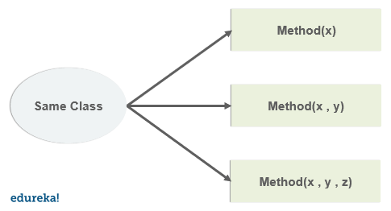

**Example Overloading:**

Class Cat {

public void sound(){

System.out.println(“meow”);

}

public void sound (int num){

for (int i=0; i < 3; i++){

System.out.println(“meow”);

}

}

}